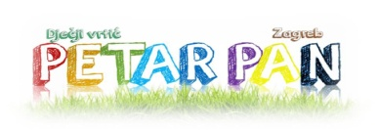
Dječji vrtić Petar Pan
Španovićeva 18, 10000 Zagreb, Hrvatska
www.vrtic-petarpan.zagreb.hr
Tel: 013750330
e-mail:vrtic-petarpan@zagreb.hr

Job shadowing schedule (29-30 May, 2018)
Tuesday, May 29
Time | Schedule
8.15-8.30 | arrival at Španovićeva, coffee
8.30-9.30 | presentation about kindergarten (plan, curriculum)
9.30-10.30 | indoor activities with children (english learning group Zebras)
10.30-10.45 | pause
10.45-11.30 | outdoor activities with children
11.30-12.30 | reflection
12.30-13.00 | lunch

Wednesday, May 30
Time | Schedule
8.30-9.00 | arrival at Španovićeva, coffee, transport to Graberje
9.00 – 11.00 | indoor and outdoor activities with children
11.00-12.30 | transport to Španovićeva, reflection
12.30-13.00 | lunch

